Arabica Coffee Beans – 1kg

This type of bean is more popular and well known among coffee lovers as it is commonly produced, and some would say it is a higher quality bean. It originates from Ethiopia and they are grown in high altitudes which need a lot of water and shade, making it easy to take care of and produce. They are high in taste and quality making it a perfect coffee bean for the perfect taste. It has a smooth, sweet taste with small hints of chocolate and sugar, making it complex and great tasting. You can use this bean with our coffee grinder machines to get the coffee taste that is familiar and known to you.

£10.00

Arabica and Robusta Blend – 1kg

This is a mix of two of the best tasing coffee beans, Arabica and Robusta. We have decided to create a special blend of these two beans as they have a different, distinct and complex taste. It has a full body and bold taste, starting off earthy and nutty flavours finishing off with a sweet taste of chocolate. This is great for those who are looking for a flavour which is different, bold and has a rich, smooth and creamy texture. It has a higher caffeine content and this new blend that we have is perfect for those who don’t know which type of coffee they like.

£15.00

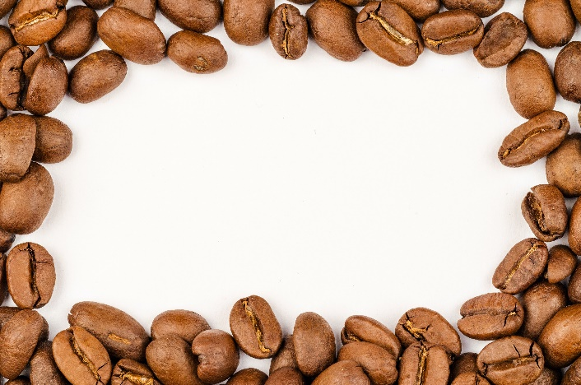Liberica Coffee Beans – 1kg

This is a rare coffee bean as they are the least produced coffee bean. They are different to other coffee beans as they are larger and have an oval shape compared to the other smaller beans. This coffee bean originates from West Africa and Malaysia and the trees that grows these beans can reach up to 17m tall, however, they have a low yield, making it hard to harvest and process these beans. The flavour profile of this bean is more intense as it has a strong aroma, making it taste nuttier and smokier with hints of dark chocolate.

£18.00

Brazil Eagle Mogiana – 1kg

This type of coffee bean comes from Brazil, Sao Paulo where it is grown in warm conditions, but can withstand cooler conditions as well. This type of coffee provides a sweet chocolatey, cherry and macadamia flavour profile which is distinct and great for those who prefer a sweeter and creamier taste. Try this type of coffee bean for a new taste and it might turn out to be your favourite! This flavour profile works well with any type of coffee drink, especially espressos and works well with our coffee grinder machines.

£10.00

Robusta Coffee Beans – 1kg

This is the second most produced coffee bean in the world. This bean origantes from Africa, Indonesia and India and it is grown in hotter climates with less water needed, and it can grow in different altitudes, making it more robust than other coffee beans. They may be small in size but they have double the amount of caffeine in them, making it a great choice for a stronger coffee taste. It has a smooth taste and texture, and combining this with milk and sugar makes it a great coffee bean choice.

£10.00